Case 6-Afr-Burkina Faso-Nwenka Mask-Bobo-Fing People-mid 20th c

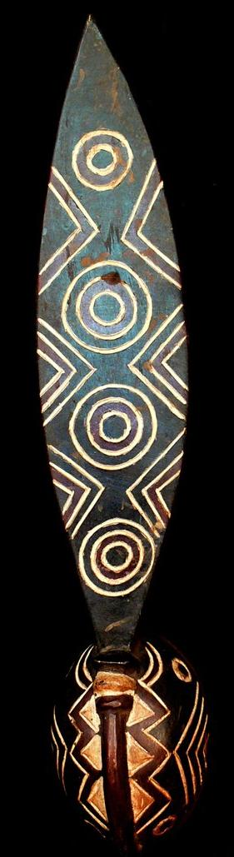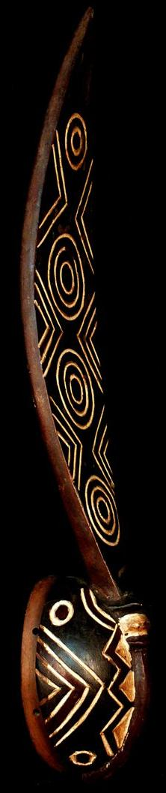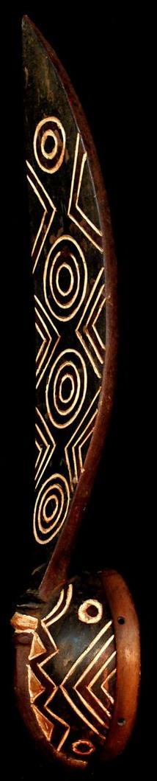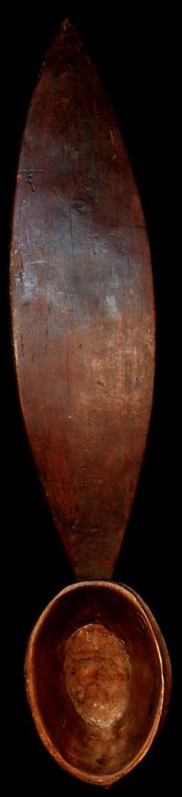

|  |  |
| --- | --- |
|  |  |

Case No.: 6

Accession Number:

Formal Label: Afr-Burkina Faso-Nwenka Mask-Bobo-Fing People-mid 20th c

**Display Description:**

This Nwenka mask is one of the oldest and most sacred designs of wooden masks of the Bobo-Fing People ("black Bobo"), who speak Bobo, a Mande language, and who live in the area of Bobo-Dioulasso, Burkina Faso. Nwenke, masks which are traditionally painted red, white, and black, reflect the three Bobo-Fing cosmic realms -- earth, upper-world, under-world -- and are worn by an elder who is masked by a raffia-fiber costume. The elder dances to a ceremonial choreography designed to emulate the chaos of creation, as an accompanying percussionist plays dissonant adagio melodies on an instrument, which sounds like a xylophone and which is constructed of hardwood slats of graduated lengths fastened tightly together with a fiber cord (Coffman 1992).

It is traditionally believed that when Wuro, the aniconic Creator, molded the world and beings from moist (unfired) clay, then Wuro created Blacksmith and his Potter Wife (Koloss 2002) to instantiate these shapes into permanent images. Thus, both husband and wife were powerful for they could use fire for creating permanent images using the power of an energy unknown to the common people (Coffman 1992). Then Wuro retreated from the (Chalcolithic) world and the beings that he had created. He left his three sons to manage maintaining its balance between opposing forces.

His most influential son, Dwo, wearing a leaf mask, which Wuro fashioned, recalls the primordial hunter-gatherer, savannah life of the Bobo-Fing People before they knew fire. This mask invoked the being of Dwo, who became the intermediary spiritual being to Wuro. Wuro, in turn, gave an image of Dwo’s leaf mask to Blacksmith who carved it in wood in the old way before metal-smithing was known, at a time when the lives of the Bobo-Fing People were surrounded by the primordial savannah. Blacksmith also carved other versions of Nwenke masks of Dwo to suggest the kaleidoscopic being of Wuro’s creation. One form was a helmet featuring a prominent forehead, circular eyes, a long, narrow nose, and a surmounting frontal, vertical plank in the shape of a leaf (harkening back to the primordial savannah) with highly expressed serrations (known botanically as an overexpression of CUC2 = CUP SHAPED COTELYDON 2, Motte et al. 2011) and with concentric circles suggesting rain-drop patterns on water. The shape of the leaf mask has certain parallels to the shape of Aloe vera, a prized anti-inflammatory plant found in Burkina Faso.

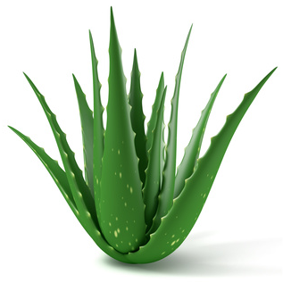

Aloe vera after https://www.facebook.com/Stephie.OUENA/

LC Classification: [PL8005](https://library.simmons.edu/search~S0?/cPL8005+.G7+1970/cpl+8005+g7+1970/-3,-1,,E/browse)

Date or Time Horizon: 6000 BP

Geographical Area: Burkina Faso

Map:

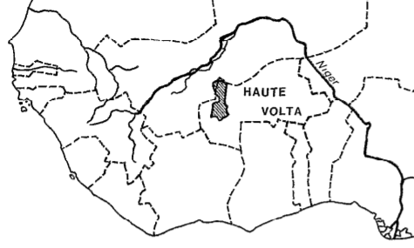

Location of the Bobo People (after Le Moal 1980).

GPS Coordinates: [11°11′N 4°17′W](geo:11.183333333333334,-4.283333333333333)

Cultural Affiliation: Bobo People

Medium: Wood and kaolin pigment

**Dimensions**: H 27.559 inches  
**Weight:** 1.303 lbs

**Provenance**: Burkina Faso

**Condition: original**

**Discussion:**

Mande languages diverged at a time horizon of 7000 years BP, on the very furthest range of what lexico-statistics can tentatively determine (Greenberg 1966). Then, its speakers were a Neolithic Proto-Bobo-Fing People, as indicated by reconstructed Proto-Niger-Congo words. As the Neolithic Proto-Bobo-Fing People technologically advanced into the copper-smelting age of the Chalcolithic, it is proposed that masks enacting the creation of the world by Wuro were first developed. Tradition based on interviews with the elderly Bobo-Fing People in 1992 indicates that they date their origins to the uniqueness of their language, that is, to the divergence of the Mande languages.

**References:**

Coffman, R. J., 1992. Burkina Faso Notebooks. MS.

Greenberg, Joseph H., 1966. *The Languages of Africa* (2nd ed. with additions and corrections). Bloomington: Indiana University.

Koloss, H.J. ed., 2002. *Africa: Art and Culture: Masterpieces of African Art, Ethnological Museum, Berlin* (Vol. 1). Prestel Pub.

Le Moal, G., 1980. *Les Bobo: nature et fonction des masques*. Paris Orstrom.

Roy, C.D. and Chaffin, A., 1987. *Art of the Upper Volta rivers*. Meudon: A. et F. Chaffin

Motte, H., Verstraeten, I., Werbrouck, S. and Geelen, D., 2011. CUC2 as an early marker for regeneration competence in Arabidopsis root explants. *Journal of plant physiology*, *168*(13), pp.1598-1601.